

Module (HTML5) -3

1. What is jQuery?

jQuery is fast, small, cross-platform and feature-rich JavaScript library. It is designed to simplify the client-side scripting of HTML. It makes things like HTML document traversal and Manipulation, animation, event handling, and AJAX very simple with an easy to use API that works on a lot of different type of browsers.

Features

* HTML manipulation
* DOM manipulation
* DOM element selection
* CSS manipulation
* Effects and animations
* Utilities
* AJAX
* HTML event methods
* JSON Parsing
* Extensibility through plug-ins

1. How to Apply CSS Using JQuery, How to Add Class and Remove Class in Jquery , JQuery Animation?

We can use JQuery to apply CSS styles to HTML elements. The css() method in jQuery allows you to get or set the CSS properties of an element. Here’s simple example:

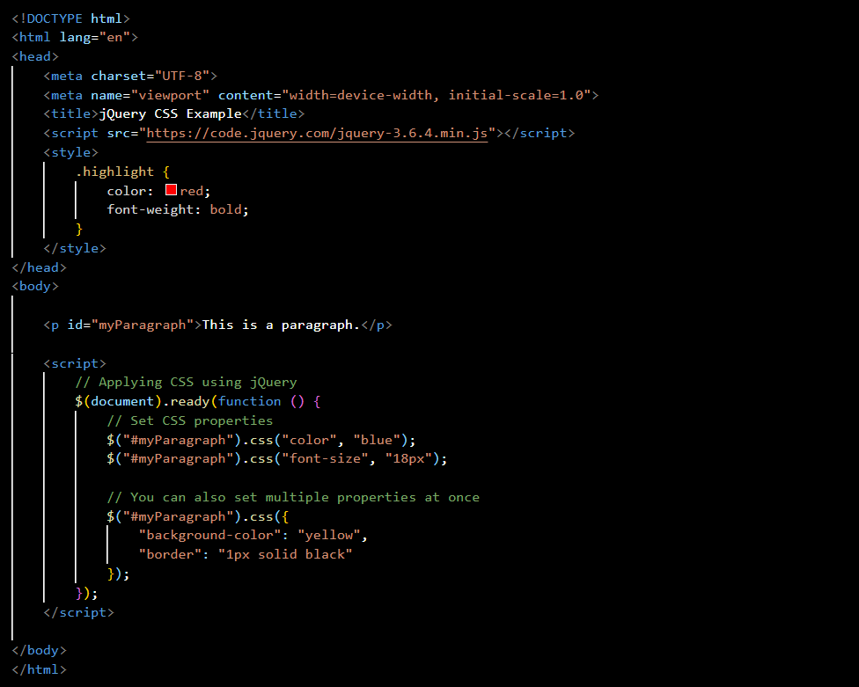

Adding and Removing classes in jQuery:

We can use addClass() and removeClass() methods to add and remove classes from HTML elements:

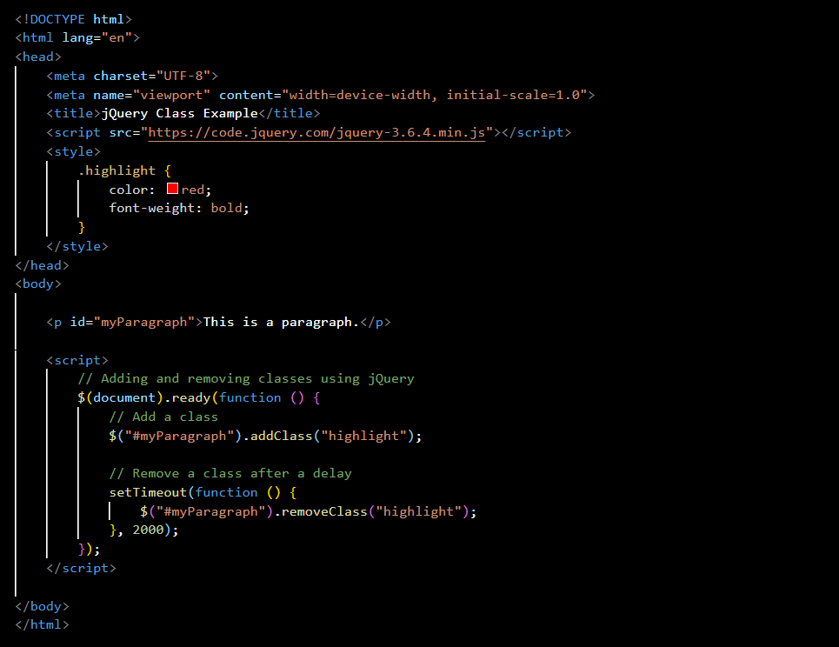

jQuery Animation:

jQuery provides several methods for creating animations. One common method is the animate() function, which allows to animate CSS properties.

Example

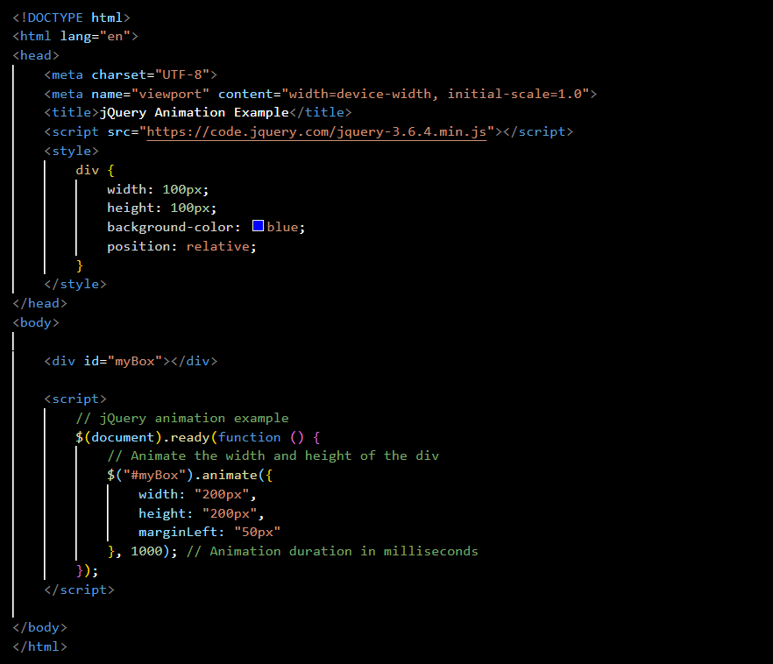

1. How to create slider with animation?

In jQuery, we can produce various types of animation using the animate() method. This method can produce simple to complex animation in the web page. Using animation, we can change the properties of HTML elements such as background colour, changing broders styles, changing navigation properties, formatting the font properties, etc.

Example

HTML elements

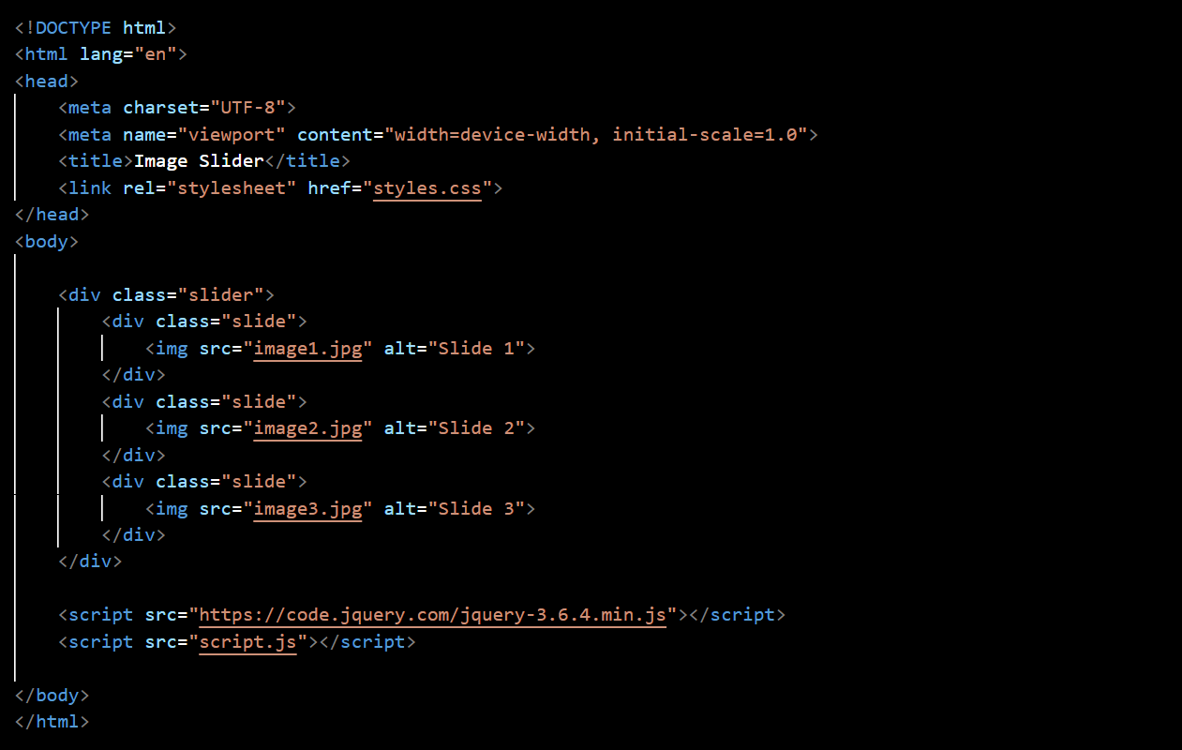

CSS

JavaScript:

